Prep
Based on the Yaz meeting notes and other notes, here are your questions for Joe:
Product & Architecture
- Walk me through the current state of merging ENGINE and AVA into a unified platform. What's the timeline, and what technical challenges are you encountering?
- The no-code "Challenge Engineering" capability is a differentiator versus RadarRadar. How mature is that feature today, and what's the bar for a customer to use it versus needing professional services?
- What does the data integration and schema mapping layer look like today? Yaz mentioned this is the main bottleneck (8 weeks down to 4 weeks). Are you building, buying, or partnering for this?
- How do you currently handle each customer's unique data structure and use case? Is there a standardized "Swarm framework" you're moving toward, or is it still fully custom per customer?
Positioning & Competitive Strategy
- Looking at SWARM (operational/AI), how are you thinking about market positioning?
- What does your competitive set really look like? Yaz mentioned o9 Solutions and Kinaxis. Who else are you losing deals to, and what are they doing differently?
- The "Agentic AI" framing is interesting. How is that different from traditional operations research or optimization vendors to a customer? What does it enable that wasn't possible before?
Product Roadmap & Scalability
- ENGINE is currently not scalable in its current iteration (per your notes with Yaz). What's the plan to fix that, and does it change your GTM or customer profile?
- What use cases are driving the most value today for your 10 customers? Where do you see the most expansion potential—workforce planning, logistics, procurement, something else?
- After go-live, what's preventing customers from expanding into additional use cases on their own? Is it product limitations, adoption challenges, or something else?
Go-to-Market & Sales
- What's the sales cycle really look like from first conversation to signed contract? What's actually in those 8 weeks pre-launch?
- Who do you need in the room to close a deal: COO, VP Supply Chain, CTO, CFO, or someone else? How does that differ by customer size or vertical?
- How much of your pipeline today comes from Shail's network versus inbound versus outbound motion? And what's your conviction on what repeatable GTM motion will work at scale?
Role-Specific Questions for Joe
- You're currently owning product as CTO. How do you think about prioritizing engineering capacity between current customer implementations and new product development?
- What's your philosophy on how much customers can configure versus customize? How do you prevent the product from becoming 100 custom services?
- From a technical standpoint, what do you think is the biggest bottleneck to getting from $1.8M ARR to the next stage? Is it the data integration problem, product scalability, GTM, or something else?
From the Yaz Meeting (Likely Unanswered)
- You mentioned wanting to enable customers to ramp up faster (target 4 weeks). What does that require on the product side, and what's your timeline?
- How do you currently measure and track customer health? Is there a formal health score, or are you still doing it relationally?
- What's the biggest reason a customer engagement stalls or underperforms after go-live?
More questions

Strategic Vision & Direction
- Walk me through your framework for defining product strategy. How do you balance customer feedback, market opportunity, and technical constraints?
- Tell me about a time you had to kill a feature or pivot strategy. What was the trigger, and how did you communicate that decision?
- How do you think about product-market fit? When do you know you have it, and what do you do if you're not sure?
- How do you decide what to build versus buy versus partner on?
- What does your 2-3 year product vision look like, and how do you test whether you're on the right track?
Working with Engineering & Technical Leadership
- How do you approach the product-engineering relationship? What does healthy tension look like versus dysfunctional?
- Tell me about your worst technical debt situation. How did it happen, and what would you do differently?
- How do you balance shipping velocity with technical quality and scalability?
- If an engineer tells you something is technically impossible, what do you do?
- How do you involve engineers in product discovery and strategy work, and why does that matter?
Prioritization & Decision-Making
- Walk me through how you prioritize your roadmap. What framework do you use, and who gets a say?
- Tell me about a time you deprioritized something important. How did you decide, and who did you have to convince?
- How do you handle the tension between deep strategic bets and incremental customer requests?
- What metrics do you use to evaluate whether a product initiative succeeded or failed?
- How do you make decisions when the data is ambiguous or conflicting?
Customer Discovery & Validation
- How often do you talk to customers, and what are you trying to learn?
- Tell me about a time you were wrong about what customers needed. How did you find out?
- How do you validate a major product hypothesis before committing significant engineering resources?
- How do you prevent yourself from building products that only you think are good ideas?
- What's your relationship with sales and customer success teams? How do they inform your roadmap?
Scaling & Growth
- How do you think about product as a driver of GTM? When does product strategy need to shift to enable growth?
- Tell me about a product launch that didn't go as planned. What happened, and what did you learn?
- How do you handle the transition from startup product thinking to scaling product thinking?
- What's your philosophy on user onboarding, and how early do you focus on it?
- How do you build products for net-new use cases versus deepening existing ones?
Culture & Leadership
- What's your philosophy on hiring for product? What do you look for?
- Tell me about a time you had to give critical feedback to someone on your team. How did you handle it?
- How do you stay hands-on while also enabling your team to own their work?
- What's your relationship with data teams and analytics? How do you ensure decisions are data-informed?
- How do you handle disagreement with your CEO or other executives about product direction?
Execution & Operations
- Walk me through a typical week for you. How do you spend your time?
- What's your process for iterating on a feature post-launch?
- How do you stay connected to what's actually happening in the product and with users?
- Tell me about your worst product miss in the last 12 months. What went wrong, and what would you do differently?
- How do you keep stakeholders aligned across product, engineering, sales, and customer success?
Innovation & Competitive Thinking
- How do you stay informed about what competitors are doing without getting distracted by them?
- Tell me about a time you built something truly novel. How did you de-risk that bet?
- How do you balance defending your core product against building adjacent products?
- What's your philosophy on white-space opportunities that engineering could technically do but might distract from the core?
- When a better-funded competitor enters your space, how do you think about response?

Mara’s questions
- What is your pitch to investors?
- What do you want from a head of product?
  - Increase revenue – ie work with customer ops more
    - GTM
    - Onboarding
  - Make you look more attractive in a sale
  - Improve efficiency in the product team – ie work with the technical team more
- Here is what you said in this video
  - SWARM notes
    - https://youtu.be/Sj1xXQ-_SJI?feature=shared
    - SWARM
    - Create a digital twin
    - Models plants
    - Model logistics
    - Model demand problems
    - Model constraints
    - millions of scenarios and a plan in
  - Customers
    - Cargill - Supply and demand plan
    - Arden t mills -production and logistics
    - Wilbur Ellis - inventory and network design
    - Frutist- labor and transport
    - Association for American feed - regulatory intelligence
    - Ardent Mills
    - Someone mentioned Google as a customer
- Noes
  - 23 algorithms
  - Needs to grow customers
  - Needs to grow customers
  - Customers want explainability in the platform
  - Thinks they might have a foothold in
    - Inventory Allocation
    - Human labor assignment
  - Screenshots
    - 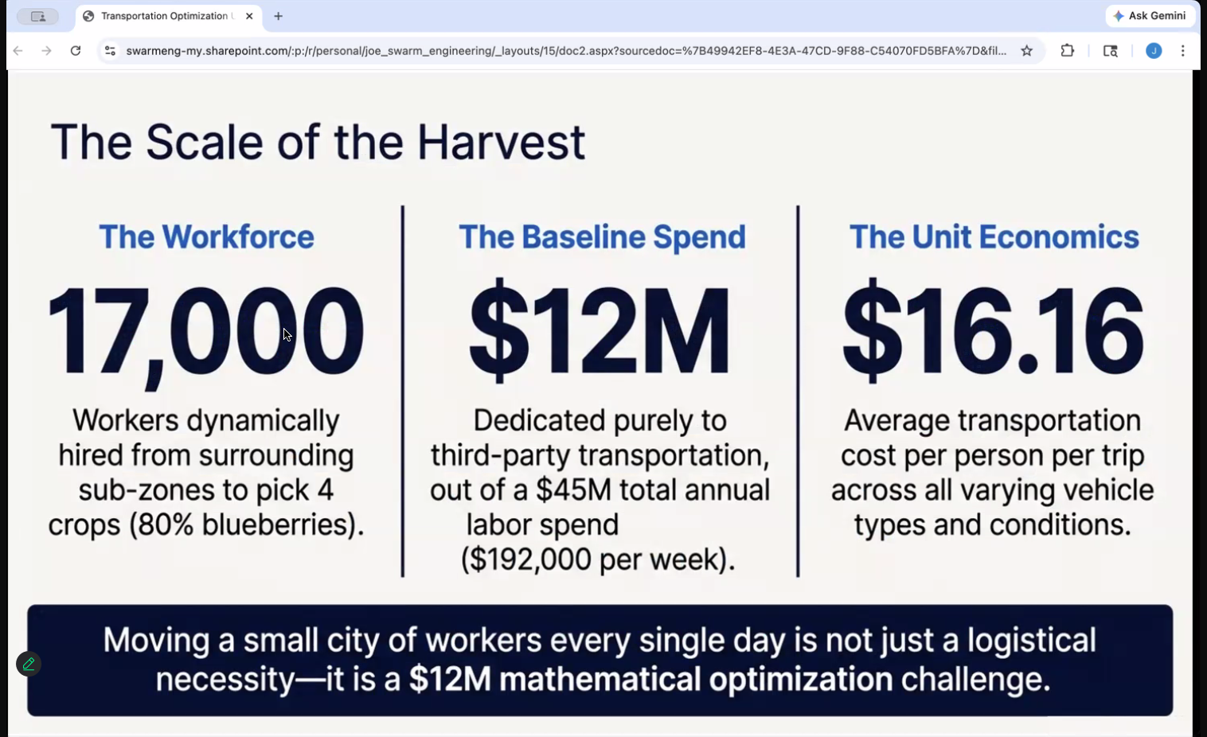
    - 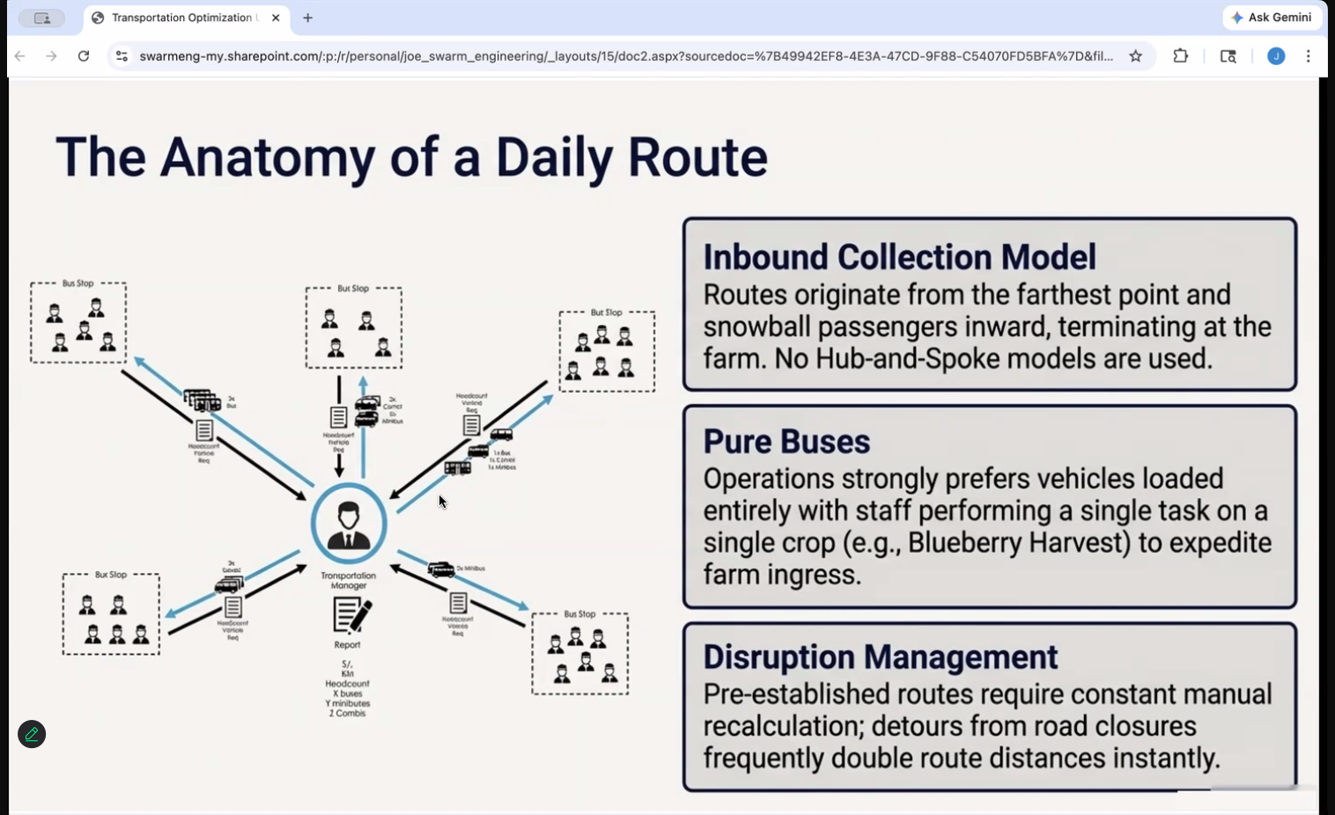

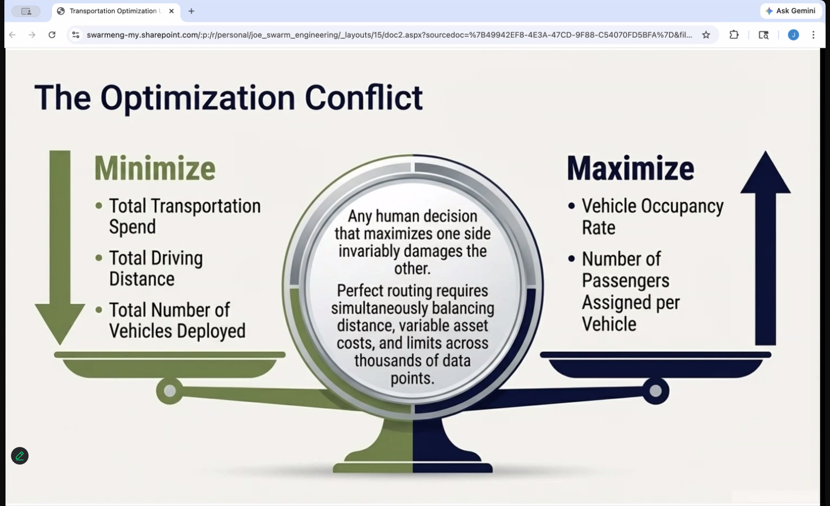
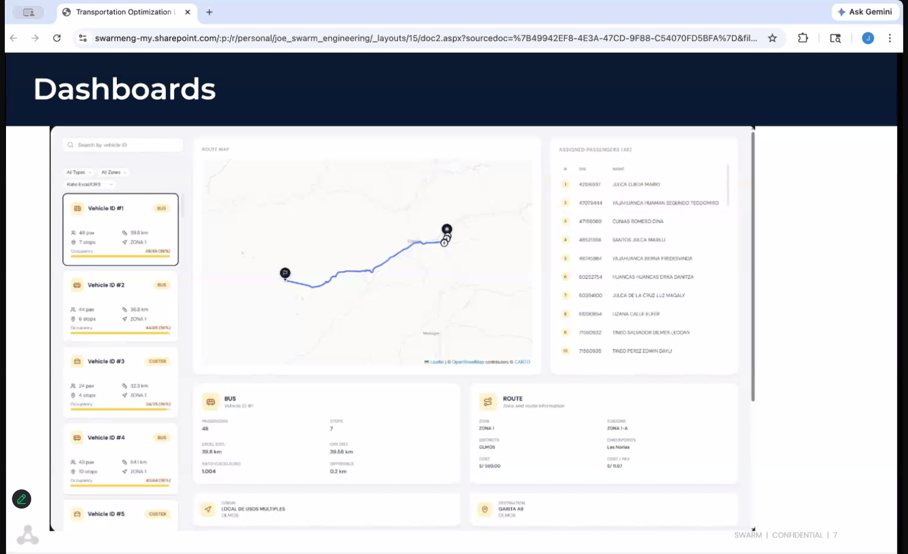
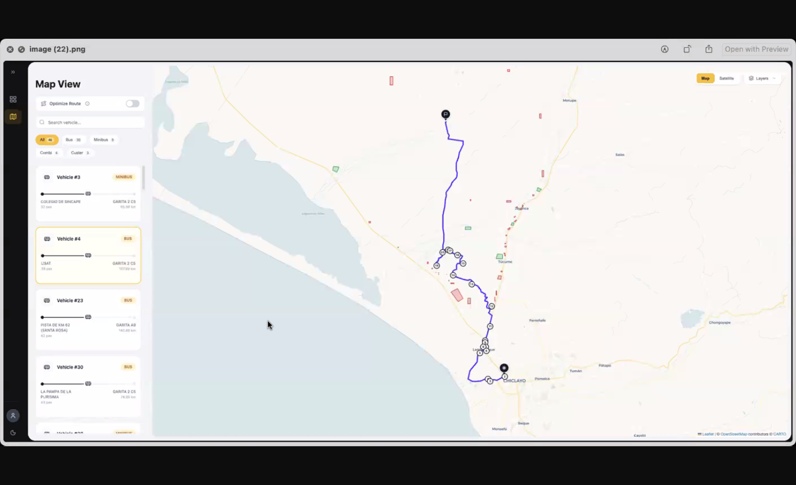Granola Notes

Swarm Company Overview & Platform
- Operations research/data science platform for supply chain optimization
- Series A company, ~1 year old with PE board members
- Engine platform: What-if scenario modeling after 8-10 week data onboarding
  - One-time setup fee (~$15K) + monthly platform fee ($10-15K)
  - Hourly to daily data integration capabilities
  - 23+ algorithms across different optimization problems
- Current challenge: “All things to everyone” vs focused product strategy
  - Board debate: Focus on few algorithms vs continue expanding problem sets
  - Sales team needs broad offering to hit revenue targets
Joe’s Role & Current Challenges
- CTO for ~1 year, joined same time as CEO Shale
- Wearing multiple hats: Technology + Product + Customer Success + Professional Services
- Stretched too thin, always reactive vs proactive
- Key frustration: Lack of capacity for strategic product thinking
  - Need quarter+ outlook vs current scrambling mode
  - Want someone to handle competitive research, voice of customer, roadmap planning
Technical Product Needs
- Looking for technical product leader who can:
  - Call “balls and strikes” on engineering estimates with sales team
  - Bridge business requirements to technical solutions
  - Reinforce that complex RFPs require significant resources ($1M+, 10 people)
- Current gap: Translating customer problems to algorithm selection
  - Goal: Less boutique consulting, more automated problem-to-solution mapping
- Product coordination issues: People bypassing roadmap, going direct to engineers
Platform Focus Areas & Traction
- Strongest foothold: Inventory allocation for food & ag
  - Most deployed algorithm with multiple customers
  - Clear path to productize vs one-off consulting
- Other repeated use cases:
  - Site location optimization (warehouse placement)
  - Human labor assignment (field workers, data center technicians)
- Recent win: Transportation optimization saving customer $500K+
  - New dashboard capabilities launched last week
  - Visual route planning for 17K workforce management
Strategic Product Direction
- Moving from “peanut butter spread” to deep focus on single problems
- Current experiment: End-to-end inventory allocation
  - Natural language interface (Ava chatbot) to solution matching
  - Automated algorithm assembly and execution
- Key product questions needing answers:
  - How far into execution should platform go? (Customer wants automated PO generation)
  - What safeguards needed for high-stakes automated decisions?
  - How to balance exploratory data work vs productized solutions?

Chat with meeting transcript: https://notes.granola.ai/t/d38f3c1f-4180-4fd7-b61c-e081eae488fa

Write follow up email

